ITS -
Added original LP No

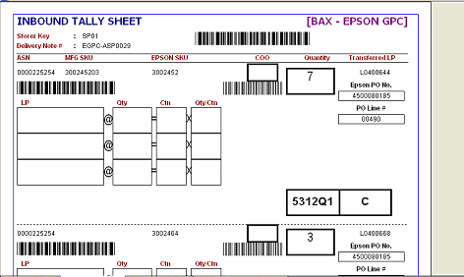
Added original LP No

